Nama :greorius agung ngoranubun

Nim : 10220054

-Controller Latihan1 simpan dalam folder Application/controllers/

­­­­­­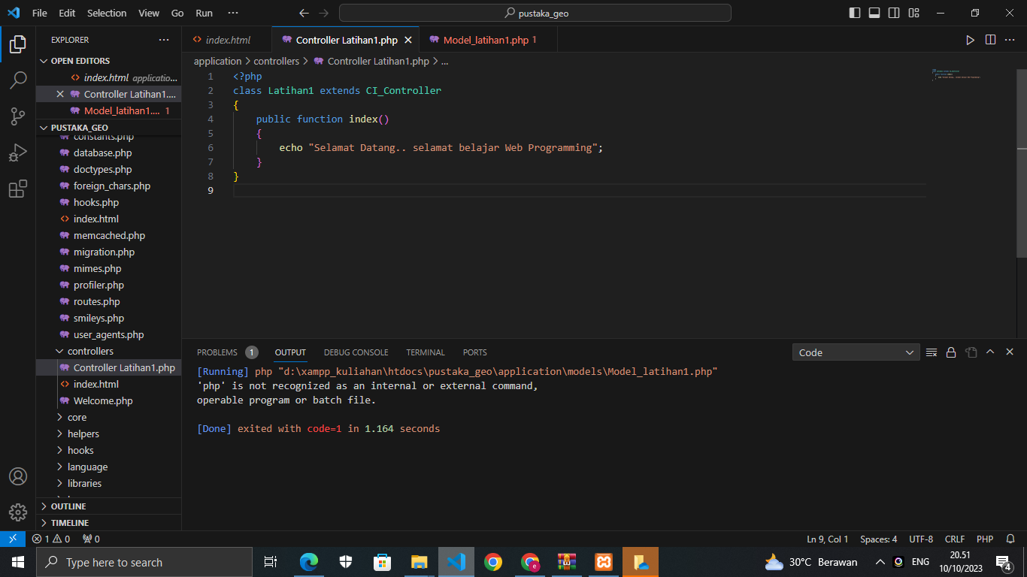

Model Model_latihan1.php simpan di application\models\

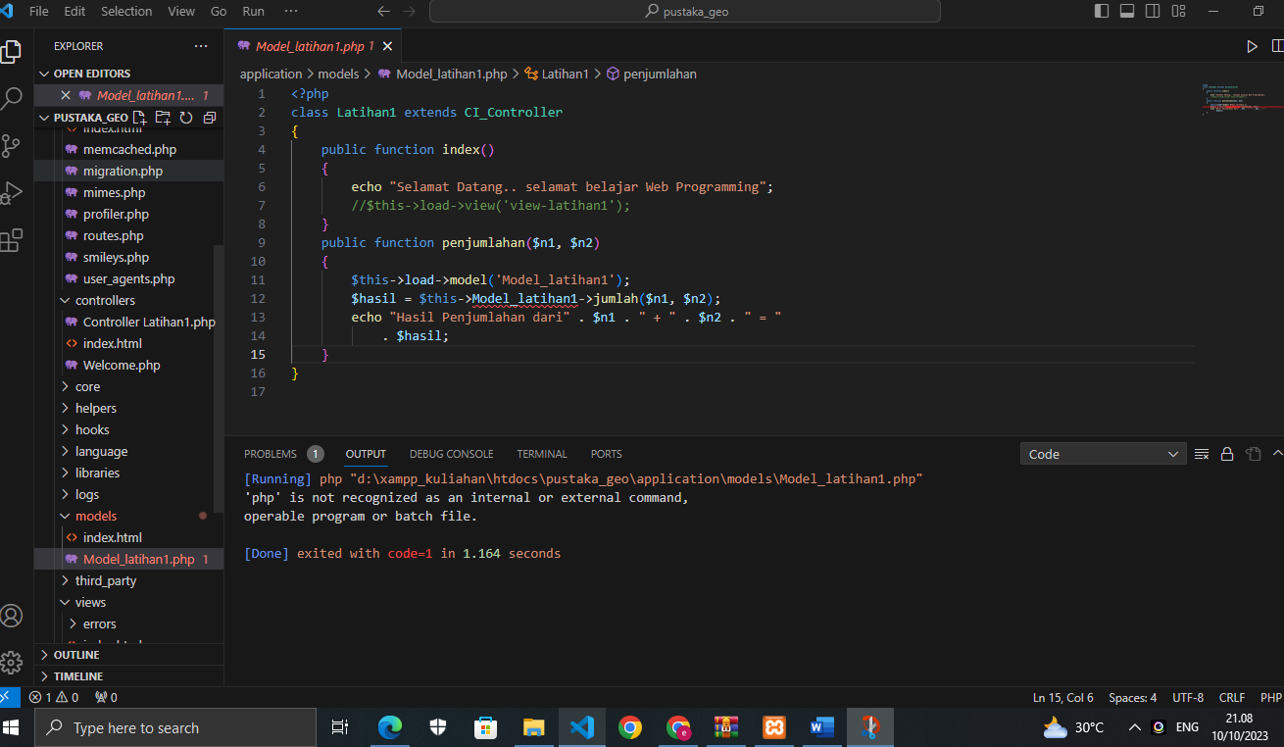

View view-latihan.php Simpan di application\views\

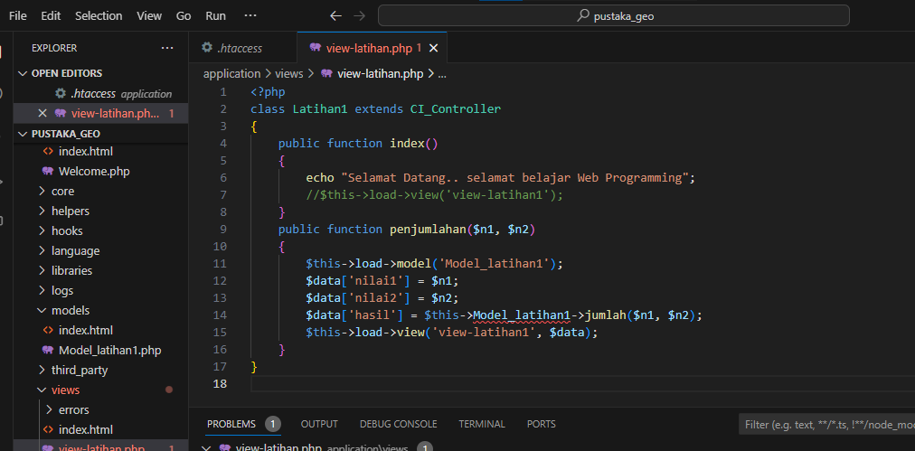

Application/views/ dan ketik script berikut:

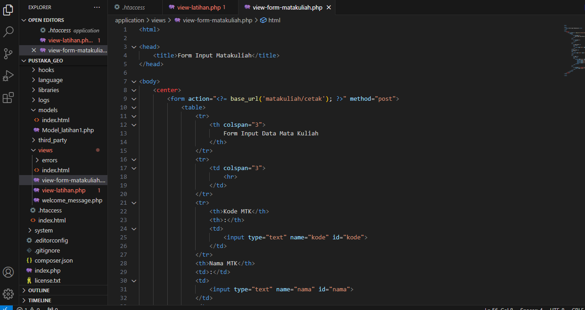

Application/controllers/